To sleep but also to breath… that’s the question

- Sleep and ventilation. The pulmonologist turns on the alarm clock (Or how pulmonary specialists have finally awakened to sleep!)
"O Sleep, rest of all things, mildest of the gods, balm of the soul …"
(Iris to Hypnos. Ovid, Metamorphoses)

“¿Qué es la vida? Un frenesí. ¿Qué es la vida? Una ilusión, una sombra, una ficción; y el mayor bien es pequeño; que toda la vida es sueño, y los sueños, sueños son” (What is life? A frenzy. What is life? An illusion, a shadow, a fiction. And the greatest good is trivial; for all life is a dream and all dreams are only dreams).
(Pedro Calderón de la Barca, La vida es sueño)

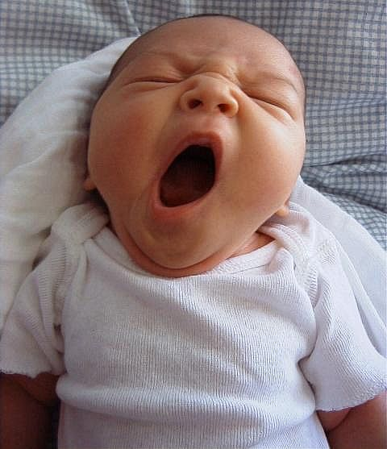
Sleep is a state of unconsciousness in which the brain is relatively more responsive to internal than external stimuli. The brain gradually becomes less responsive to visual, auditory, and other environmental stimuli during the transition from wake to sleep. Sleep may be likened to a journey: the somnolent brain begin in a stage of drowsiness and progresses, in an orderly sequence, to more profound stages in which the sleeper becomes progressively more insensitive to stimuli.
Sleep entails a profound alteration in human physiology. And as many other physiological functions, ventilation is profoundly modified by sleep. The body position, the control of breathing the airflow resistance, the ventilatory response to loading and the synchronization of the respiratory pump muscles between them but also in relation to upper airway muscles are all different in sleep compared to wakefulness. In fact the respiratory system is challenged by sleep. The command activating the respiratory muscles is extrinsic and characterized by two components originating in the central nervous system. One is automatic, autonomic and vital; it maintains continuous ventilation and ensures its adjustments for homeostasis, the other is conscious, behavioral and voluntary. Sleep, characterized by the abolition of the later becomes exclusively dependent on automatic control. Moreover, during sleep the loss of wakefulness stimulus is associated with a decreased ventilatory muscle tonic activity. But regulation of respiratory rate is not restricted to the thoracic and abdominal muscles: from the spatio-temporal viewpoint, ventilatory commands pass first by the upper airway dilator muscles that contract at onset of inspiration, before reaching the diaphragm and the muscles of the ribcage. This strict coordination ensures opening of the glottis and stabilizes the upper airways preventing collapse which could be caused by negative intrapharyngeal pressure. This precise coordination could be lost during sleep.
When the respiratory system is in a disease state, sleep may represent an additional challenge that may exceed the response capabilities of the system and lead to failure. This is all the more so if respiratory failure is already present during wakefulness. It have been well demonstrated that sleep related hypoventilation is the first sign of ventilatory failure preceding daytime chronic respiratory failure. Moreover, quality of sleep could be profoundly altered in respiratory failure patients

2) Ventilation and sleep. Pulmonologist night fever
(Or how pulmonary physicians spent nights to scrutinize how well patient and ventilator
fraternize…)

Then the Lord God formed the man of dust from the ground and breathed into his nostrils the breath of life, and the man became a living creature
(Genesis 2.7)

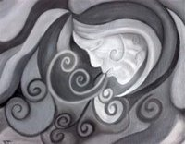
In the last 20 years, non invasive ventilation (NIV) has become an established and proven therapeutic modality leading to prolonged survival and decrease in morbidity in a variety conditions leading to respiratory failure.
Non invasive ventilation is usually applied during the most challenging period: sleep. This seems logical: the goal is to improve ventilatory function in the more fragile period. But, when NIV is started, the ventilatory parameters are determined empirically based on clinical evaluation of underlying disease, patient tolerance when awake, and diurnal blood gas variations. Modulating NIV settings during the day, underestimating these physiological differences may lead to suboptimal patient-ventilator interaction that may reduces NIV efficacy but also alter quality of sleep. Moreover, NIV uses a non-hermetic technique, which poses the possible risk of leak. Leakage may be absent when the patient is awake and may worsen during sleep as a result of the loss of voluntary control and decreased muscle tone. There is well known that leakage itself may lead to sleep fragmentation.
Therefore a patient could consider to be well ventilated when:
- The ventilator provide a proportional assistance to his needs without limiting the expression of its own respiratory activity
- There are obvious signs of improvement or correction of alveolar hypoventilation
- ….but also an improvement or, at the least, preservation of sleep patterns
Consequently, NIV effectiveness needs to be assessed by sleep studies. The gold standard to this assessment is performing a polysomnography to evaluate at the same time both efficacy of ventilation and quality of sleep. Interpretation of this type of study requires some know how to score sleep but also to understand patient ventilator interaction.

3) Sleep, breathing,.. old and new
(or some mythological issues)

….J’ai bien tort de te réveiller! Pourquoi réveiller celui qu’on aime ? Dans son sommeil tout le pousse vers vous ! Des que ses yeux sont ouverts, il vous échappe ! (…I am well wrong to awake you! Why awake someone that one likes? In its sleep all pushes it towards you! As soon as its eyes are opened, he escapes to you!)
Ondine (Jean Giraudoux)

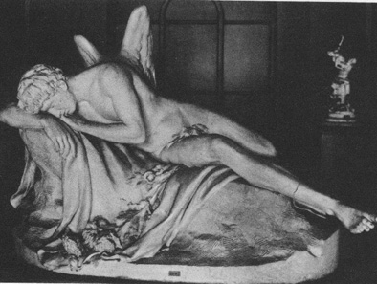
Myth I: In the Greek mythology Hypnos represent Sleep and Dream. He is the younger brother of Thanatos (Death), and Nyx (Night) is the nurse of both. It has been ordained that Hypnos and Thanatos should have all things in common. Hypnos, the younger, imitates the other in everything. He had been surnamed 'the Bountiful', for this is the god who puts cares to flight protecting them of the blowing of winds, and soothes the bodies of both mortals and immortals

Myth II: The myth of Ondine, tell the story of a water nymph who had an unfaithful mortal lover. He swore to her that his "every waking breath would be a testimony of [his] love", and upon witnessing his adultery, she cursed that if he should fall asleep, he would forget to breathe. Eventually, he fell asleep from sheer exhaustion, and his breathing stopped. Ondine's curse is now a medical term applied to a rare syndrome where the autonomic (involuntary) control of breathing is lost, resulting in the need to initiate every breath consciously. Untreated, patients with Ondine's curse supposedly will - like Ondine's unfaithful spouse - die if they fall asleep.

Hypnos and Thanatos. Sleep and Breathing …. From mythology to physiology.
Just another brick in the intriguing Labyrinth of the Eternal Return.

